Staging Site Changes – 29.10

1
Treatments Page Done
https://wordpress-1379640-6536820.cloudwaysapps.com/clinical-remedial-massage-practice-essendon/
Can you please make sure the headings and colours matches the heading on the website? Change these:
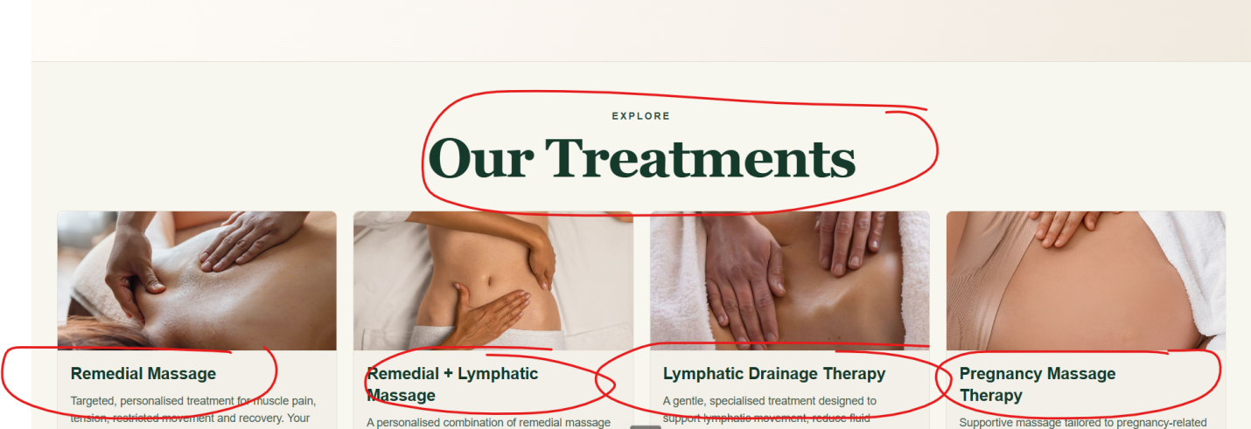

Change the small heading text colour to brown to match the style of the other small headings.
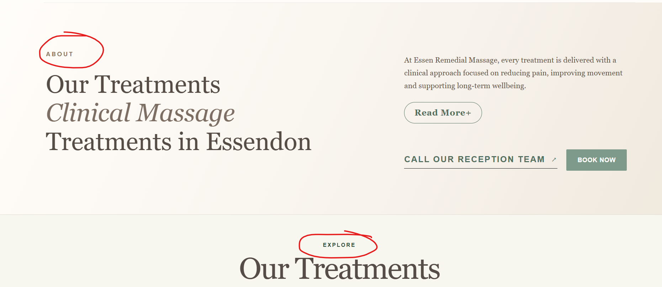
Change Our Treatments style to this:


2
Top Banner Done
Change the font of this to Montserrat, the same font as the menu:
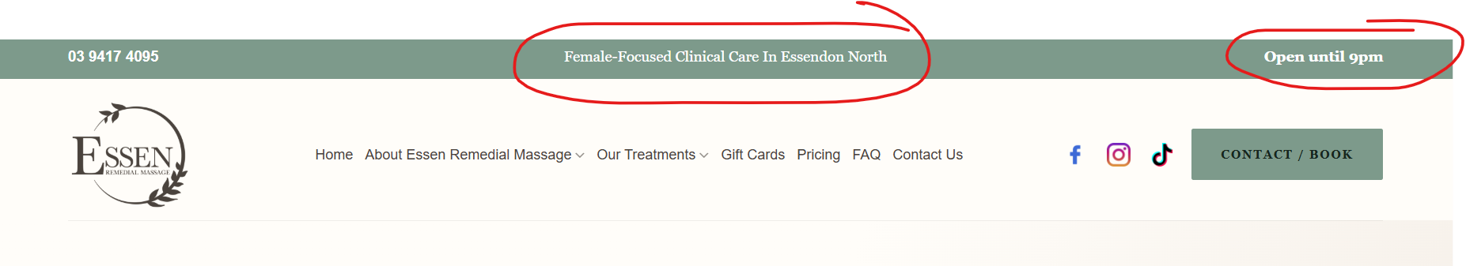
Add an icon to the phone and Open until 9pm
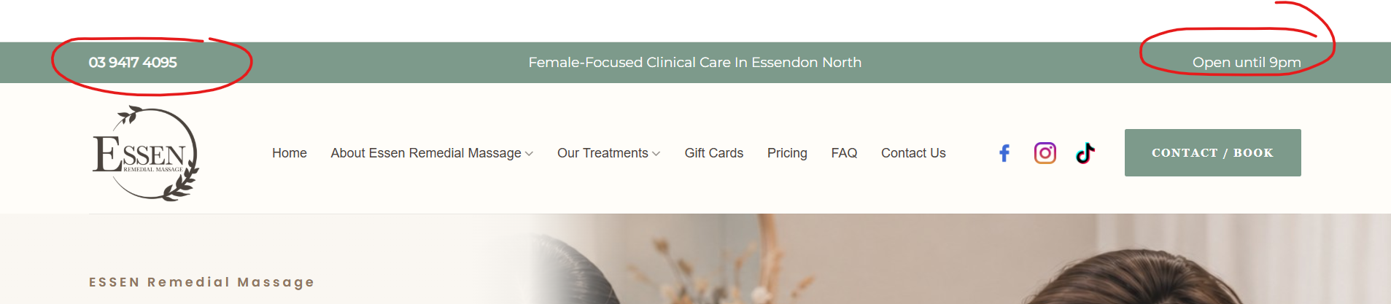

3 Done
Change all button text colour to white
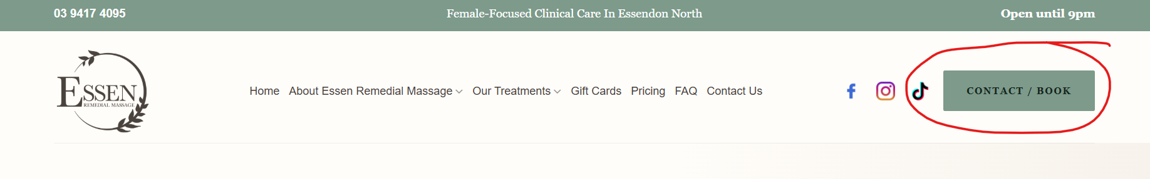

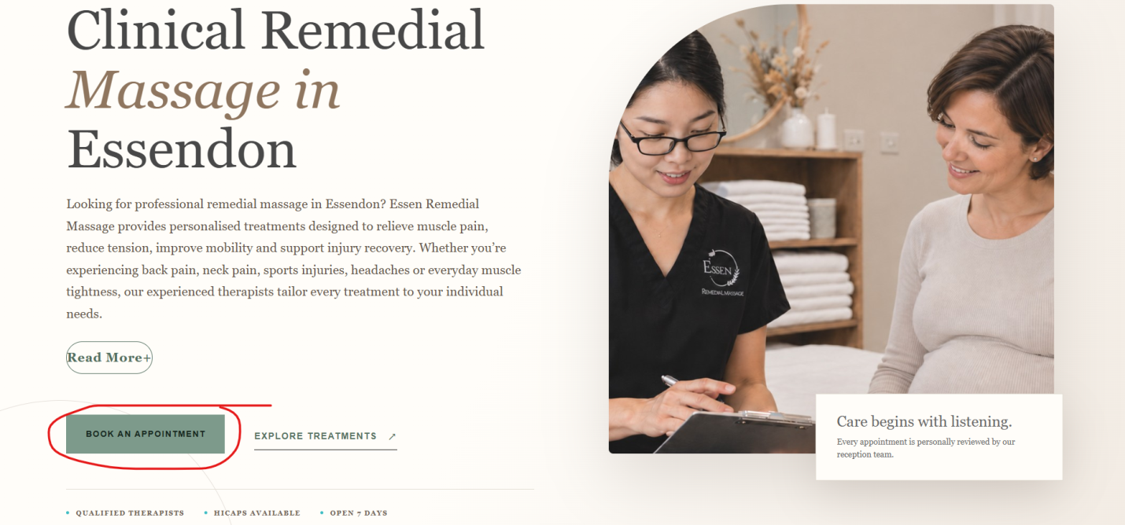

4 Done
Read More button
Fix the Read More link format:
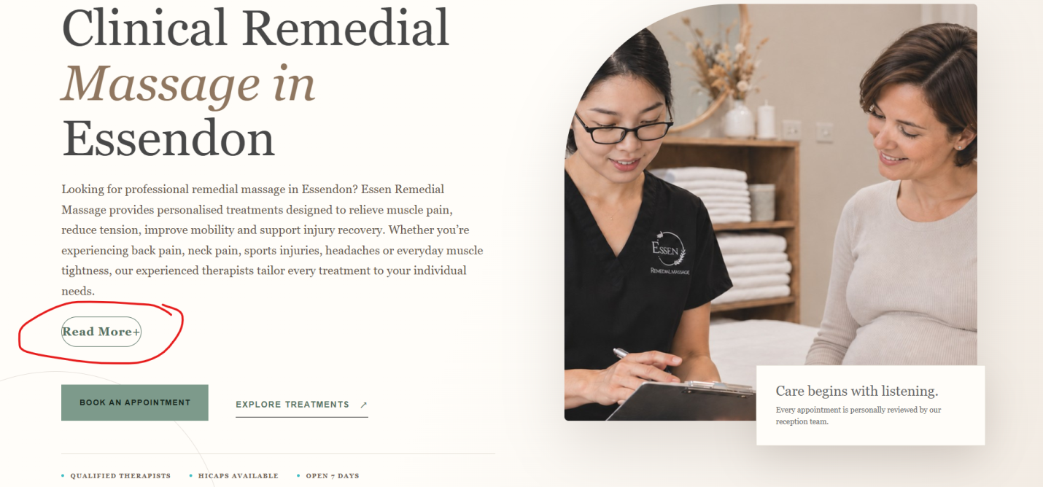
5
Pricing Page Done
https://wordpress-1379640-6536820.cloudwaysapps.com/pricing/
Change the header to match the headings on the site and change the colour to match the branding of the website (sage, cream, white)
Add a Book Now button below
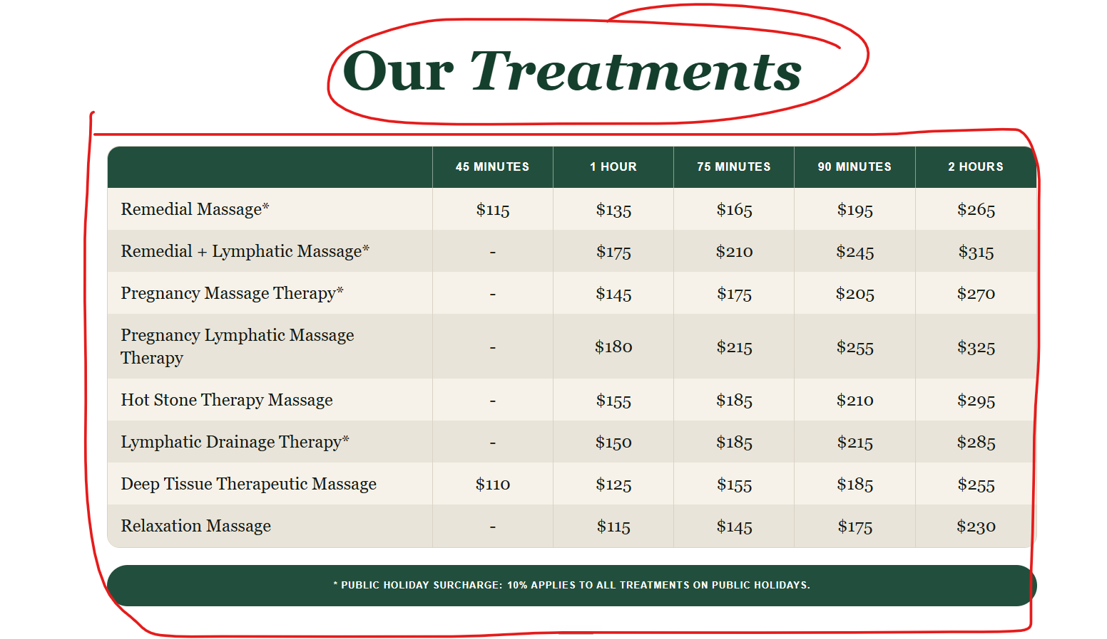
e.g
Reference layout, content and updated pricing from the customer. Follow the layout but keep our branding colours the same as the rest of the site:
- headers to be the same as the other headers
- table colour to be in sage green
- book your appointment to be the same colour as the one on the screenshot below)
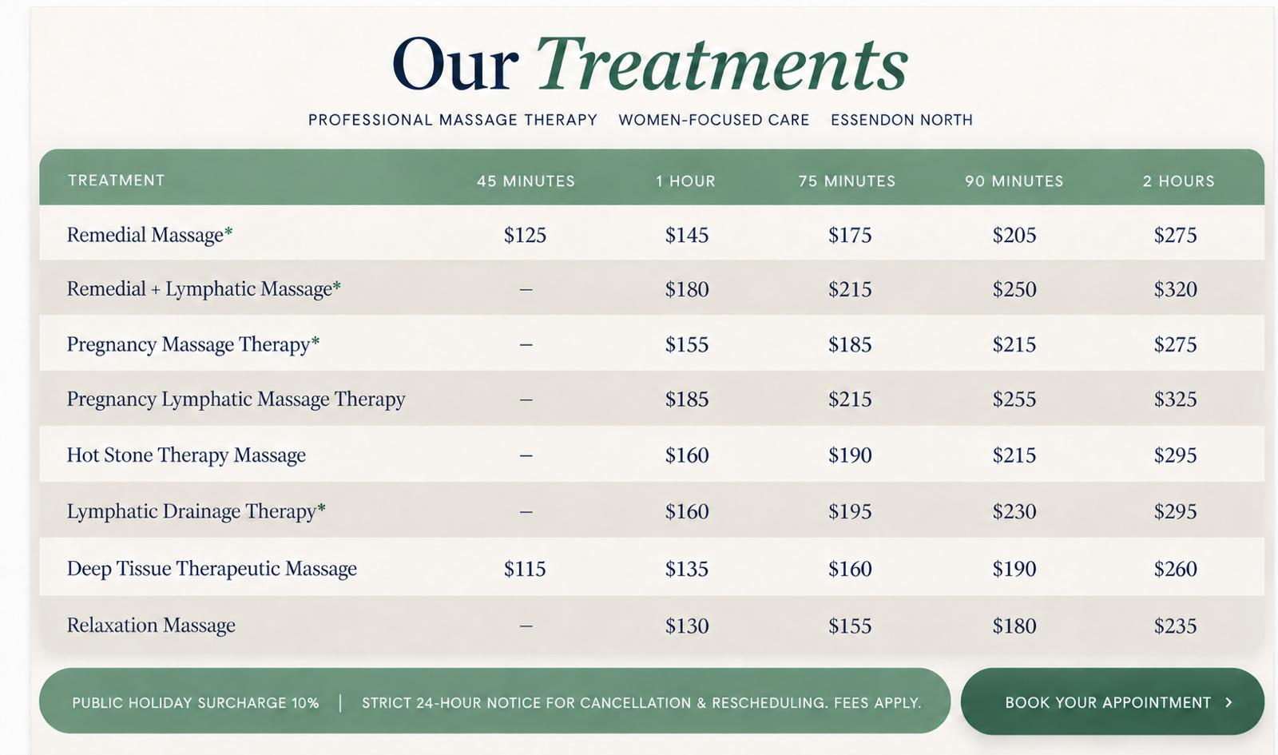
Make Book Now a button:
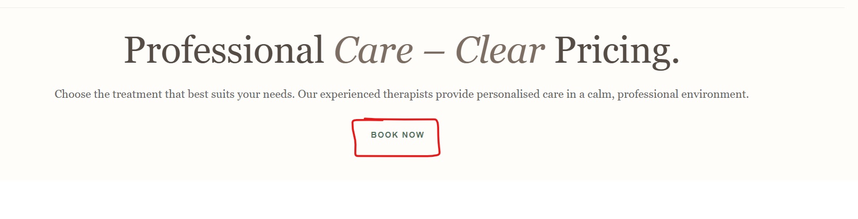
Change the colour of the table content to white and light grey and make the Book Now button wider and slightly darker in colour
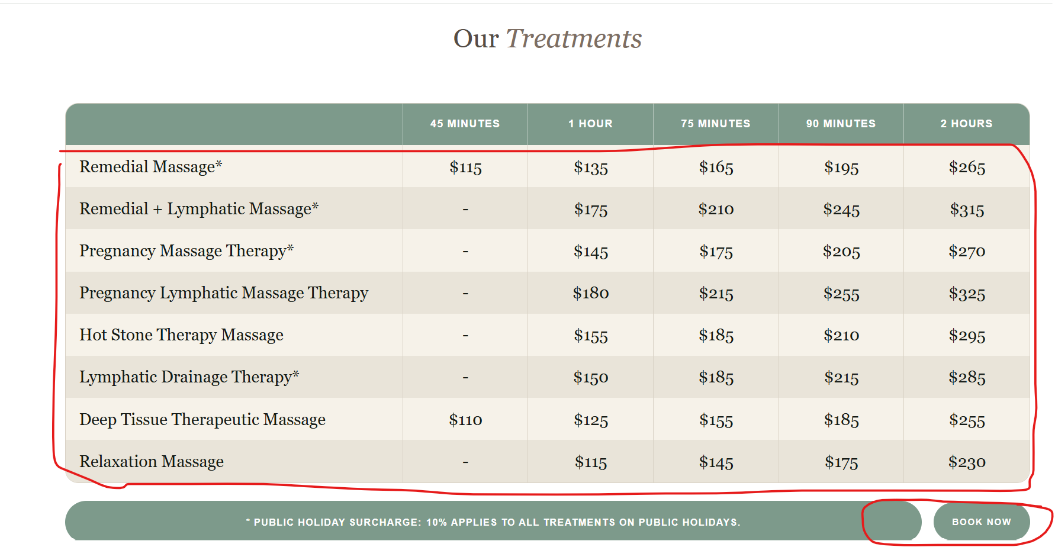

6 Done
All FAQs
Change the FAQ image to the FAQ image attached.
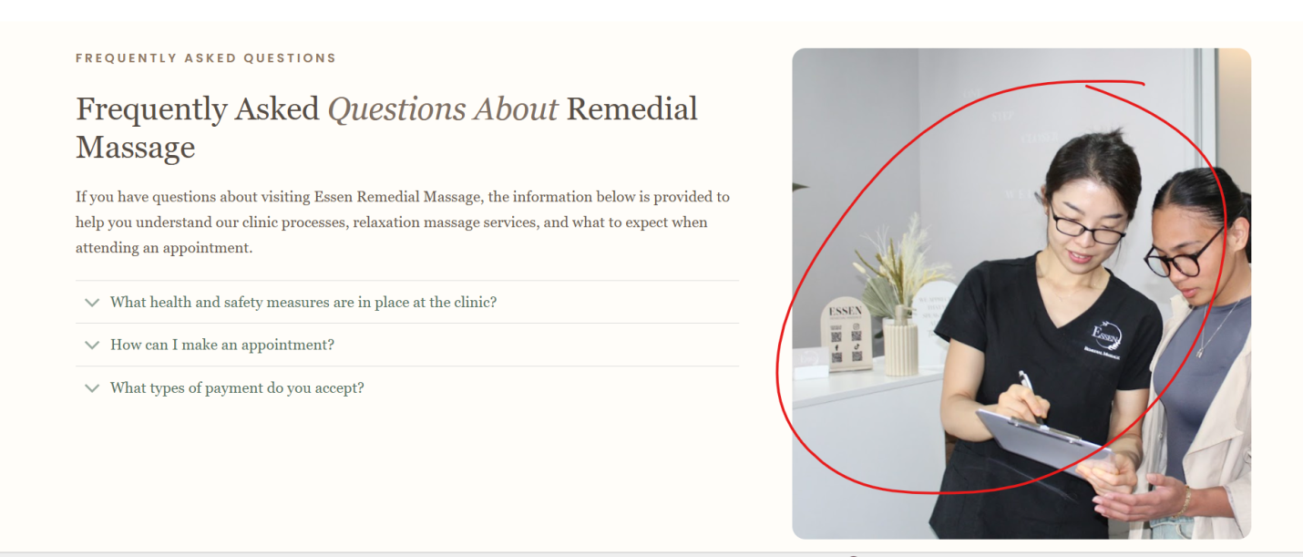
7 Done
All Treatment Pages
Make “Contact Us” into a button:
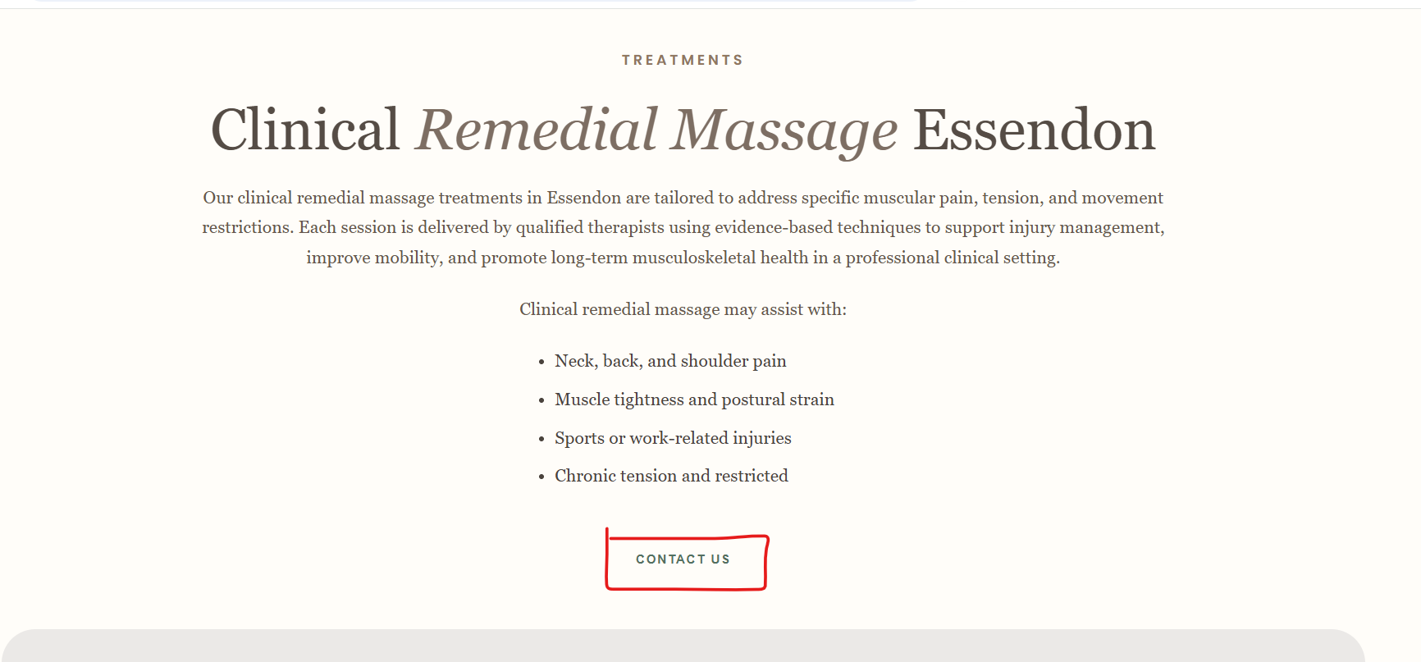
Only have the 1st paragraph visible and add a read more link to hide the other content sections on the banner.
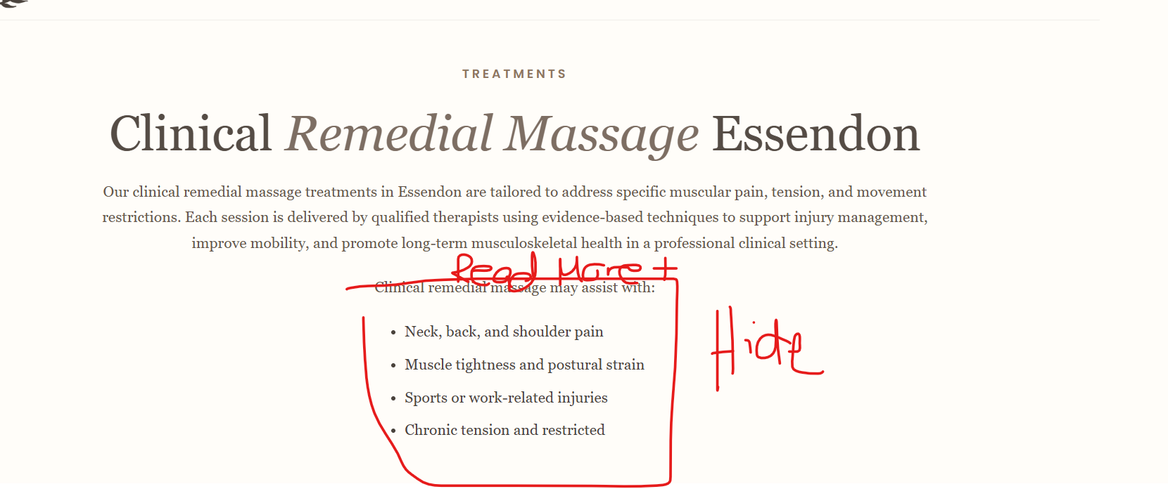
Change background of the testimonials as sage doesn’t blend well. Can you recommend a different colour.
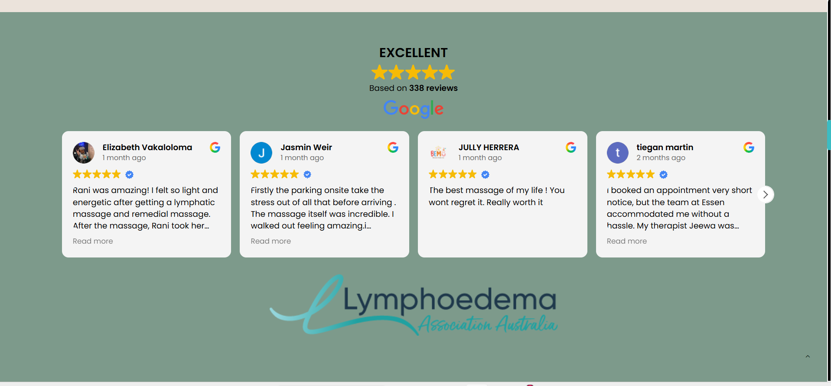
Change FAQ background colour to #EBE3DB
Change “Understanding Clinical” background colour to #F6F6F6
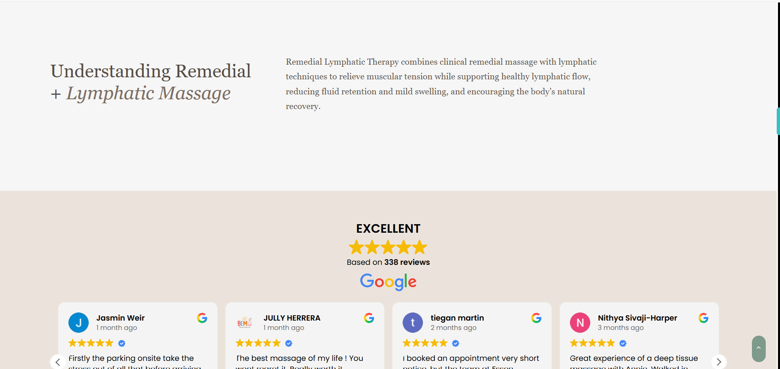

Change the FAQ image to the FAQ image attached. – This hasn’t been done. Use the image attached
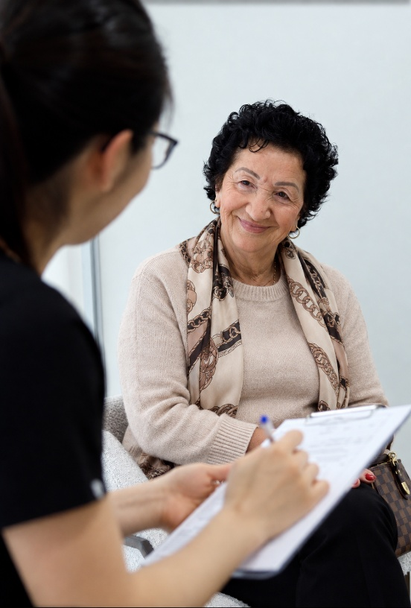
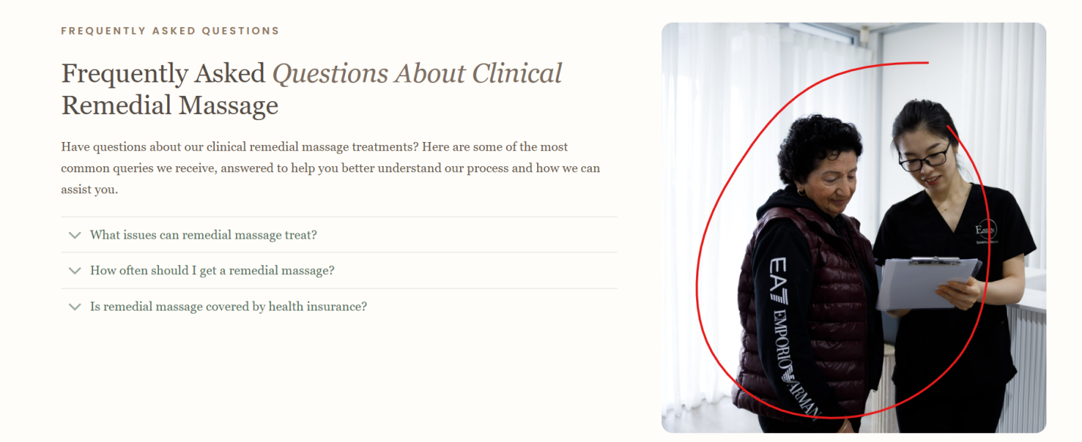

Change all pixelated Rani’s image to the new image I sent: _47A0449.jpg
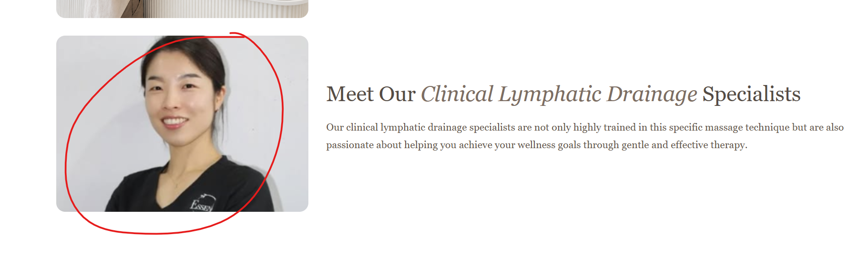

8 Done
Footer
Make the sage green background a little more darker to have contrast

9 Done
https://wordpress-1379640-6536820.cloudwaysapps.com/our-treatments/clinical-relaxation-massage-essendon/
Remove this sage background:
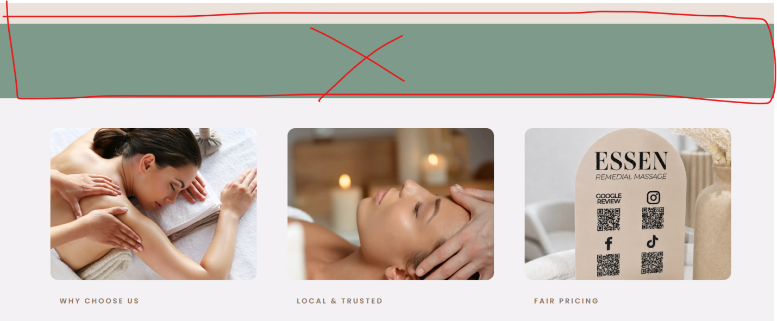

10 Done
Contact Page
Change icons to sage green
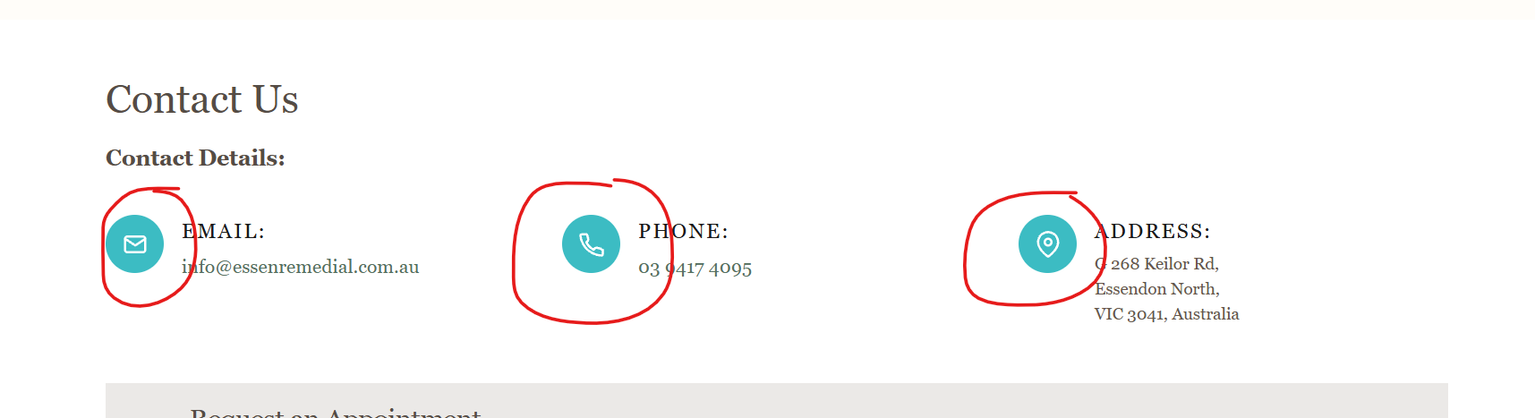

11 Done
Gift Cards
Make button colours consistent
Sage background and white text:
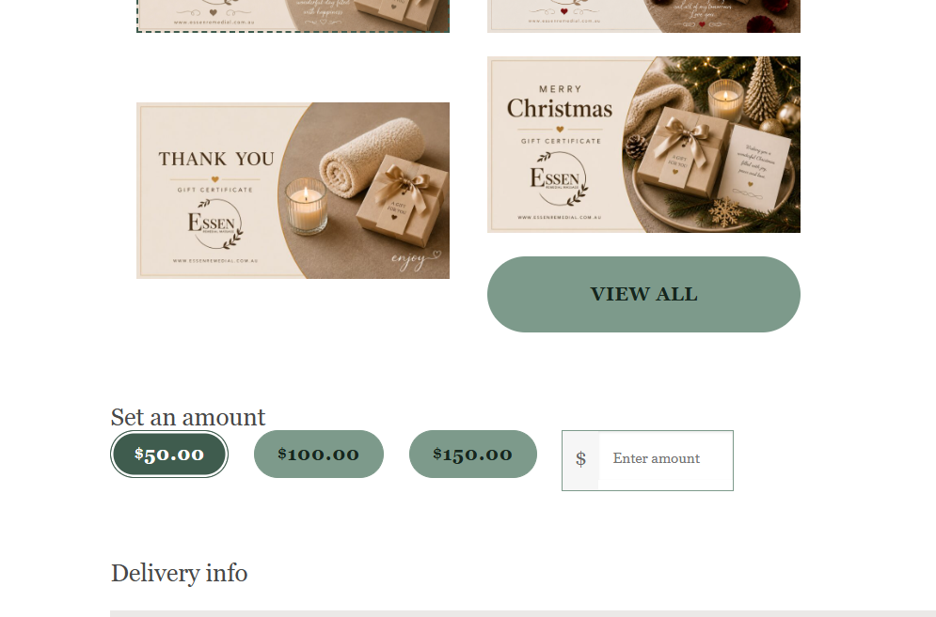

12 Done
Home Banner Image
The customer would like to not crop the ladies in the photo. Is this possible? If we need to change the shape of the image, please do that.
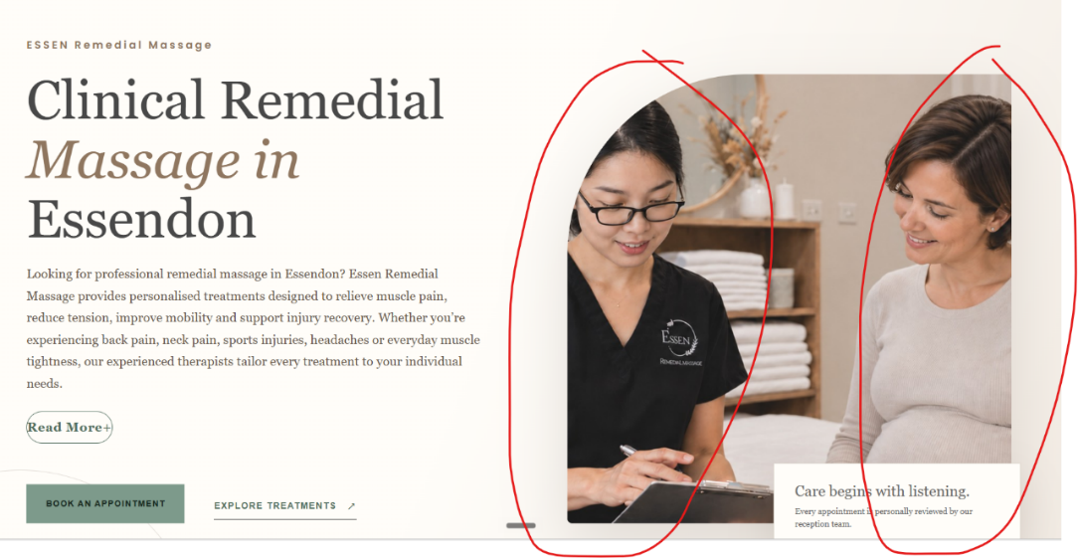
This looks cutoff. Please fix asap
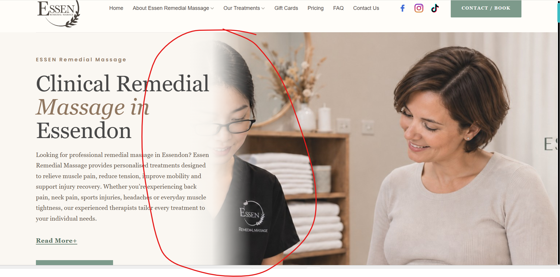
13 Done
Pregnancy Lymphatic Massage Image
Can you try to generate an AI image similar to the style of the Pregnancy image:
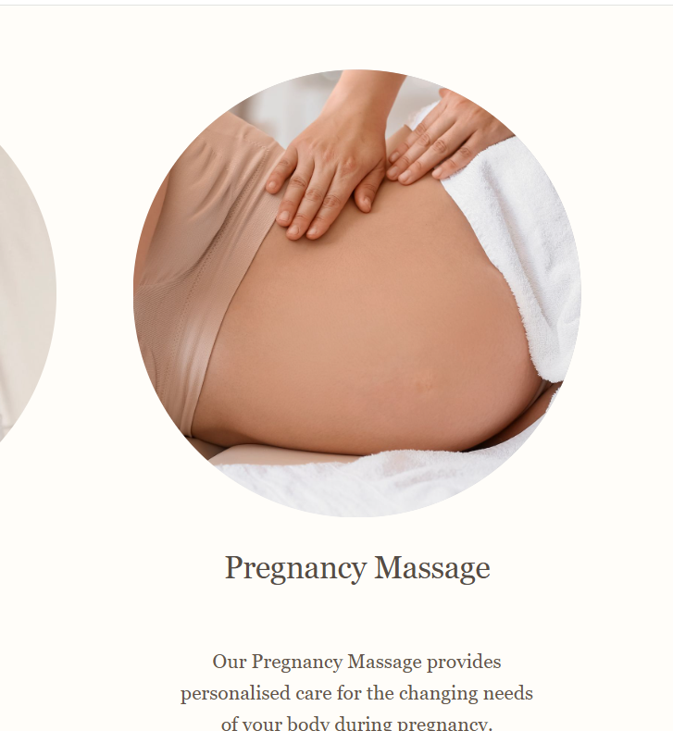
Change this image across the staging site:
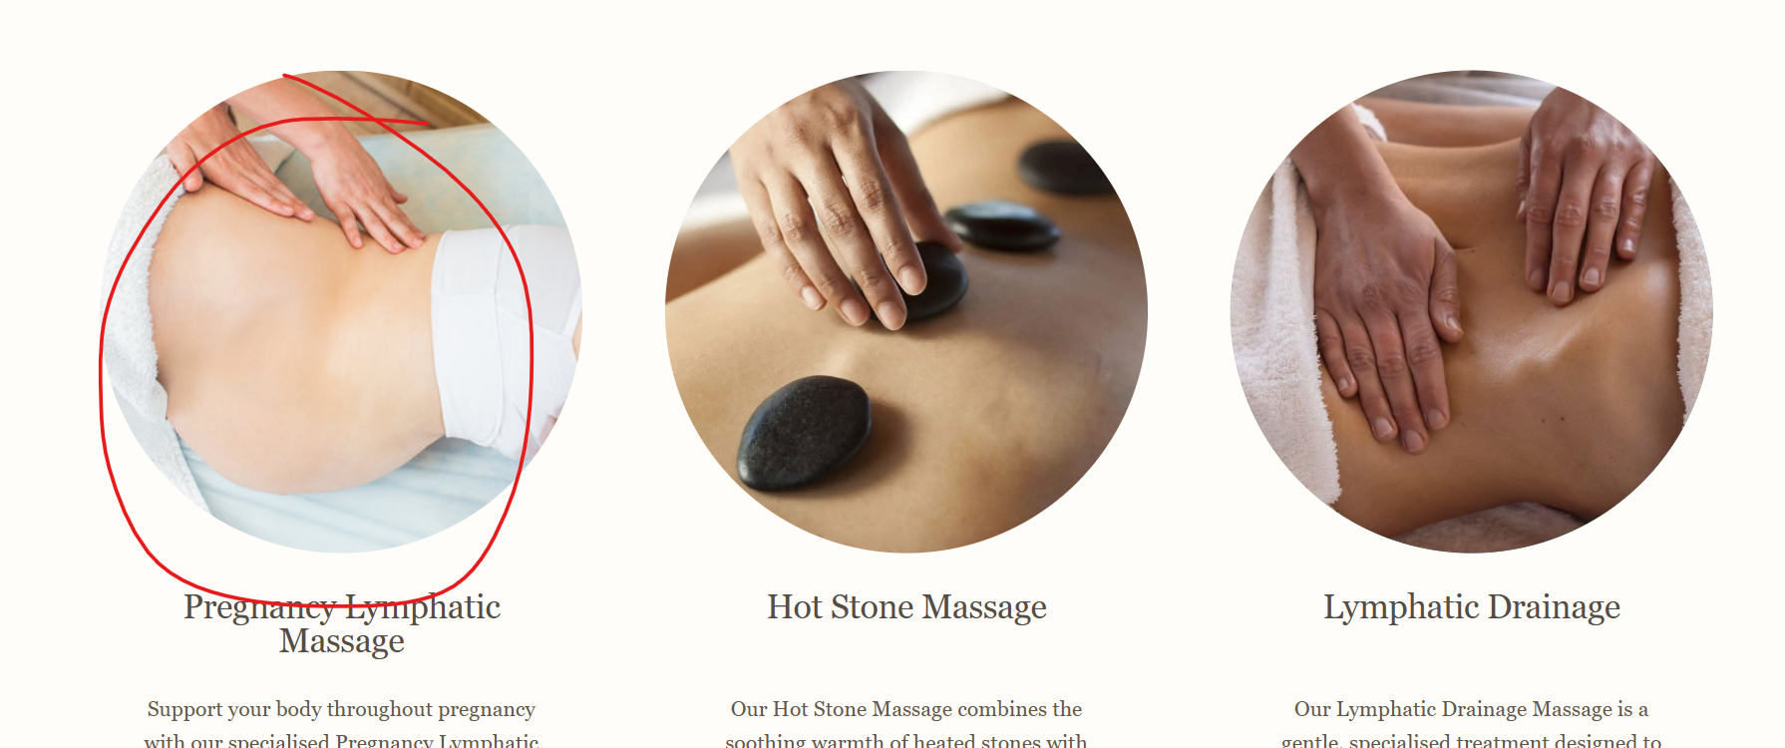
Change all Pregnancy Lymphatic Image to the new image attached.
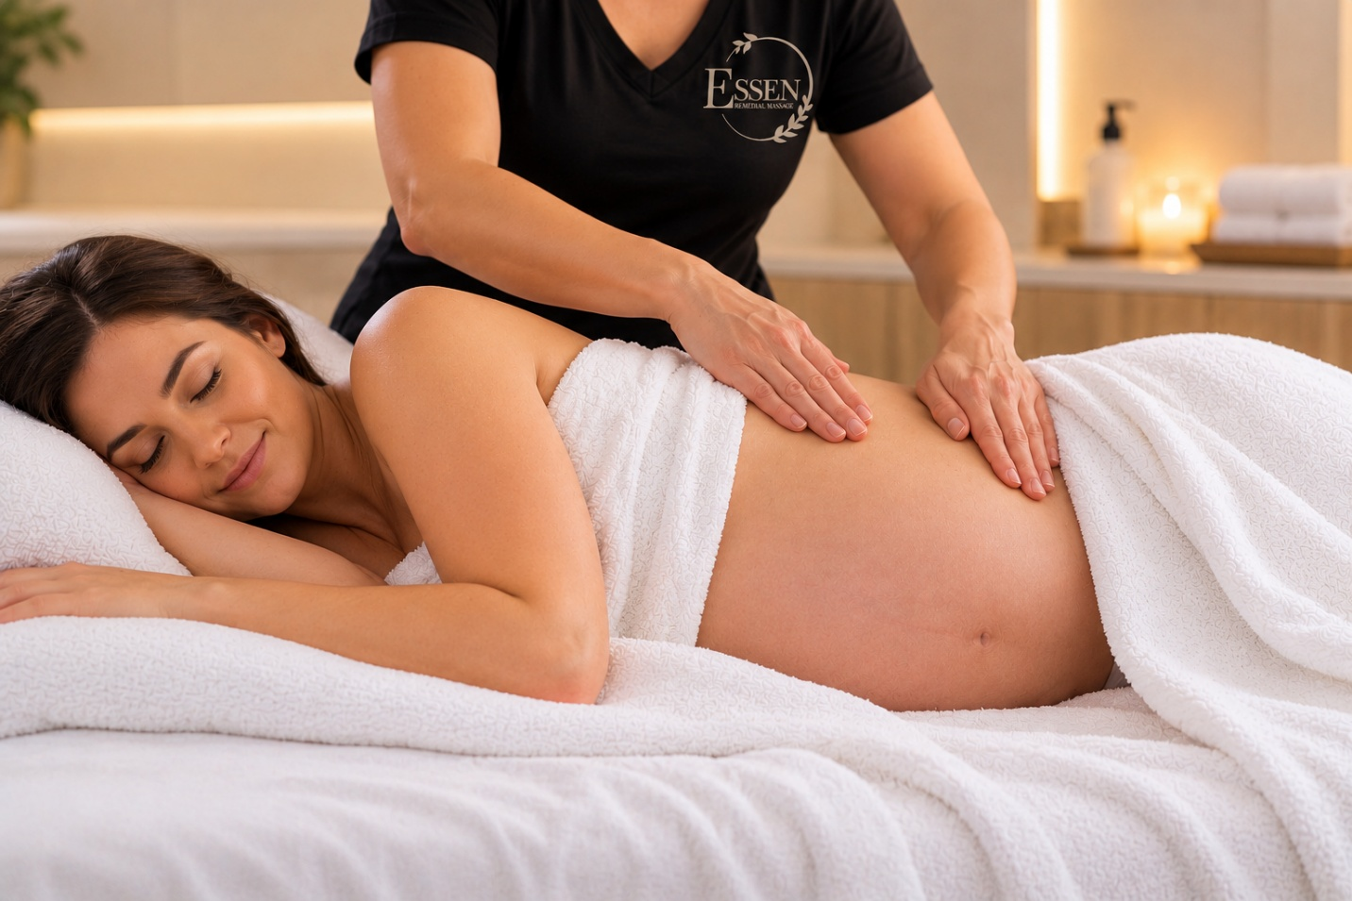

14
Change Where to Find Us background to white


